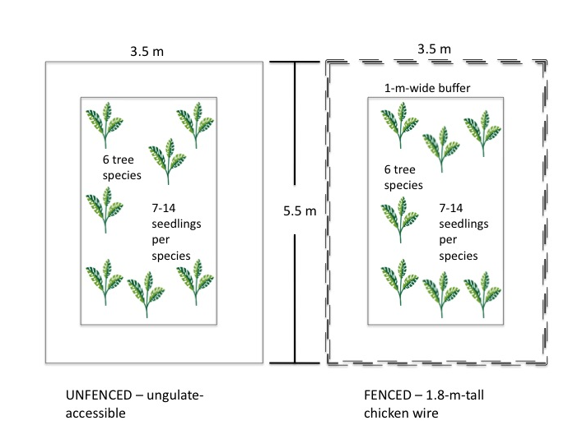

**Figure 1.** Design and dimensions of seedling plots.Seedlings of six different species of trees were planted in paired plots. Paired plots are not necessarily next to one another, but within 10 m of each other.

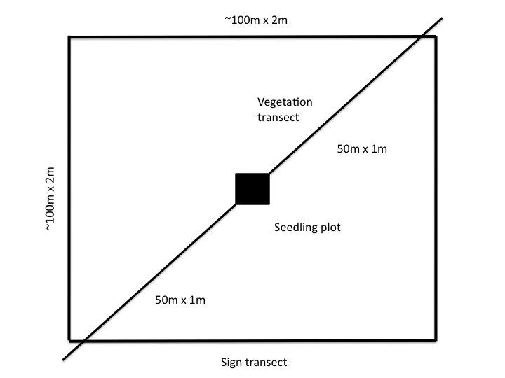

**Figure 2.** Design and dimensions of vegetation and ungulate-sign transects. Two 50-m by 1-m transects were used to survey vegetation. Scats and other ungulate sign were counted along these transects and additional walking transects, in approximately a 100-m by 100-m square. The opaque square in the center depicts the seedling-plot exclosure that was present at most, but not all, of the sites.

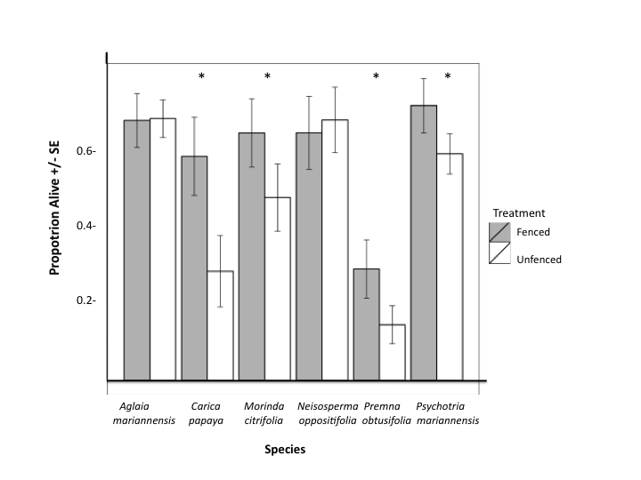

**Figure 3.** Survival in seedling plots.Treatment by fencing or removing ungulate access affected seedling survival, indicated by “proportion alive.” Error bars show one standard error of the mean. Significant effect on seedling survival based on log likelihood ratio test of models with and without treatment.

**Figure 4.** Manly Selectivity Index values (*B*) for native and exotic plants. Manly Selectivity Index values were higher for native species in pig scats collected from Anao North and Ritidian Gate. Error bars represent 95% CI calculated for *B*.

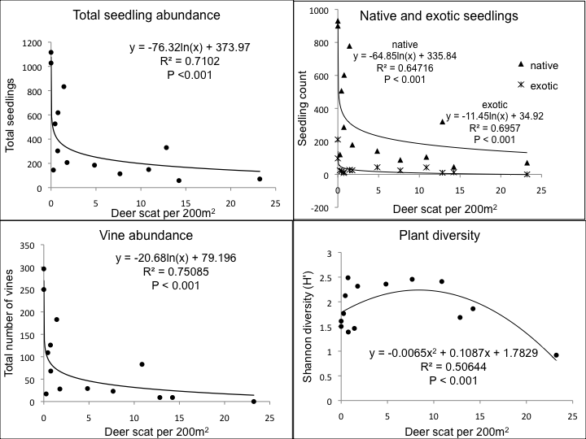

**Figure 5.** Native and exotic seedling abundances, vine abundance, and plant diversity, as measured by Shannon diversity (*H’*) and their relationships to deer abundances across sites, estimated using scat counts.